**Library web service**

The site represents a library system which help users to find desired books.

**Books and authors catalog**

User can see books in a catalog and information about them. Each book has a few authors; an author writes a few books. Also, there is a list of author where a reader may find desired books and authors.

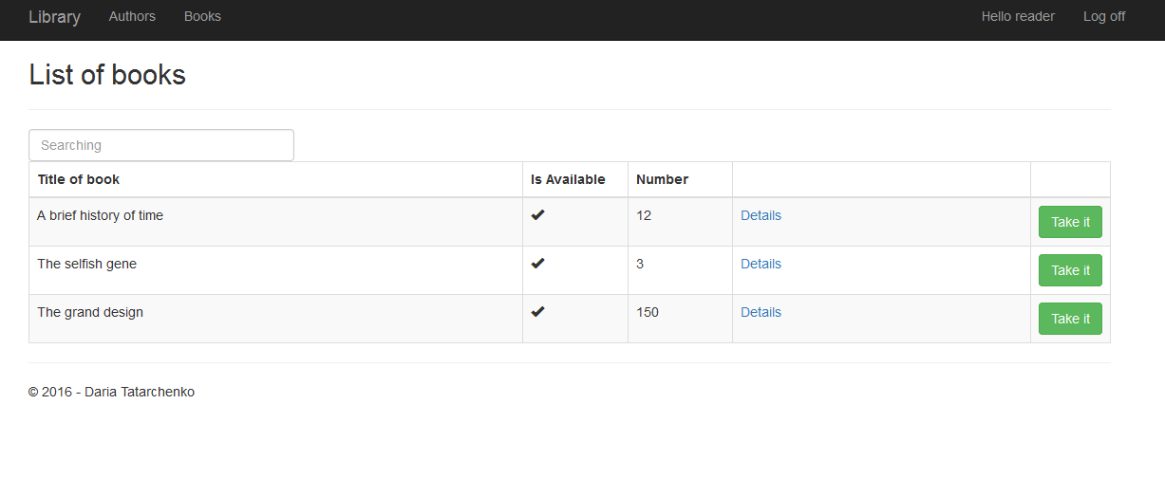

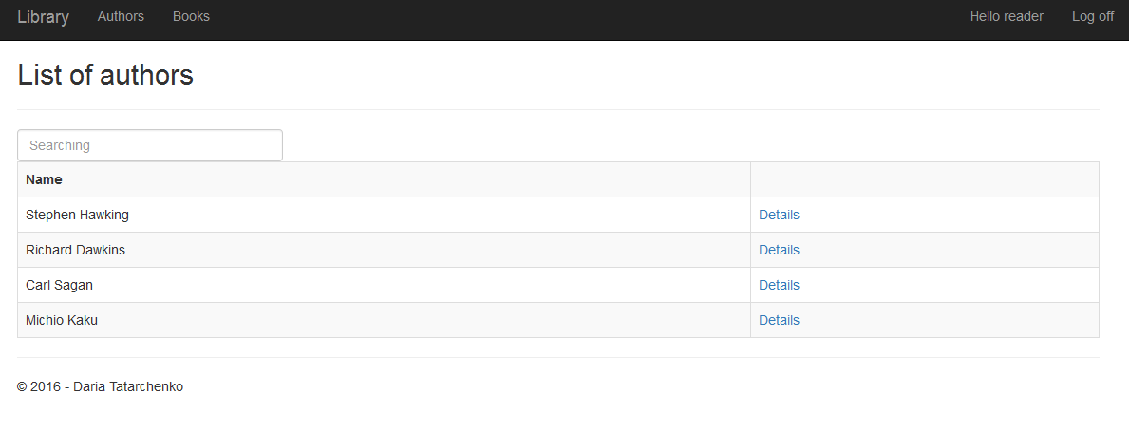

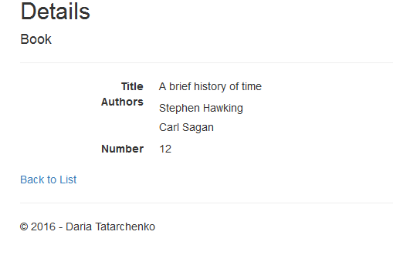

**Registration**

Registration is necessary for taking a book. User just have to enter his e-mail to sign up. He will get notification via email if he takes a book. Also reader can take a book only when it is available.

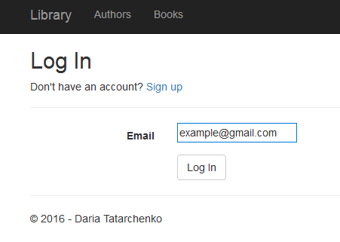

**Admin rights**

For getting admin rights it is required to enter to system with e-mail [admin@admin.com](mailto:admin@admin.com). Admin can create, change information about book, delete it and assign an author to each book. Moreover, he sees history of books (who took a book and when).

